Supplementary Material

Feedstock chemical characterization
Compositional analysis to determine structural carbohydrates, lignin, extractives, and protein was performed at NREL following the standard Laboratory Analytical Procedure for Compositional Analysis [1]. Proximate, ultimate and elemental ash analysis of the biomass samples were carried out by INL. The selected feedstock samples were ground with a Retsch ZM 200 centrifugal mill using a 200 µm screen. A thermogravimetric method using ASTM D5142 was used for proximate analysis. For moisture content, the LECO TGA 701was heated to 107 °C and held until a constant mass was reached under a nitrogen flow of 10 standard liters per minute (slm). The crucibles were capped with ceramic covers, and the temperature was then ramped to 950 °C and held for 7 minutes to determine volatiles content. Ash content was determined by cooling the instrument to 600 °C, removing the covers, and switching the gas to a flow of 3.5 slm of oxygen. The temperature was then increased to 750 °C and held until a constant mass was reached. Fixed carbon was calculated from the weight loss during the ashing step. Ultimate analysis of the feedstocks, using a LECO TruSpec CHN and S add-on module, was conducted using a modified ASTM D5373 method (Flour and Plant Tissue Method) that uses a slightly different burn profile of 4 slm for 40 s, 1 slm for 30 s, and 4 slm for 30 s of UHP O₂. Elemental sulfur content was determined using ASTM D4239-10, and oxygen content was determined by difference. Heating values (HHV, LHV) for the feedstocks were determined with a LECO AC600 Calorimeter using ASTM D5865-10. Elemental ash analyses of the ground samples were carried out by Huffman-Hazen Laboratories (Golden, CO).

Bio-oil and char analysis
A number of analyses were performed to characterize the liquid and solid products from the 2FBR. Moisture, fixed carbon, volatile carbon and ash were determined on an as-received basis on all oil and char samples using a LECO TGA701 carousel thermogravimetric analyzer using the ASTM D5142 standard method. Carbon, hydrogen, nitrogen and sulfur content were measured via high temperature combustion in oxygen followed by infrared analysis using a LECO TruSpec CHN module with a TruSpec Sulfur add-on module. The oxygen content was determined by difference from the C, H, N, S and ash measurements. All measurements were performed at least in triplicate.

Water content of the bio-oil was determined by Karl Fisher (KF) titration. Samples were vigorously shaken for 60 to 90 s to suspend any heavy material that had settled. Approximately 100 µL of oil was transferred to the KF vessel which was preconditioned to an anhydrous condition and titrated to the instrument end point. Each sample was measured in triplicate. Prior to titration, the KF reagent was standardized against a NIST traceable water standard.

Bio-oil viscosity was determined using a Brookfield DV2T viscometer. Samples were shaken for 60 to 90 s to suspend any heavy material. The oil was drawn up into a syringe and approximately 0.5 mL sample was passed through a 0.47 μm filter and placed into the sample cup of the viscometer. The spindle rpm was adjusted to provide a constant torque (25 ± 5% of full scale) to the sample. After conditioning the sample at 24 ± 1 °C for 2 min., the viscosity reading was taken using a three minute average. Each sample was measured in triplicate. Prior to measurement of the first sample, the instrument performance was checked against a viscosity standard.

TAN (total acid number) of the oils was determined by automated titration. Samples were shaken for 60 to 90 s to suspend any heavy material. Approximately 0.5 mL of oil was dissolved in 60 mL of ethanol and titrated against 0.5M NaOH aqueous solution. The titration rate was adjusted automatically to limit the rate of pH change to 20 mV/min, thus providing adequate equilibration time, and the TAN value was obtained at the last equilibrium point. The NaOH solution was standardized against a potassium acid phthalate standard and the instrument performance was verified by titrating a known weight of 2-methoxy-benzoic acid in ethanol.

Carbonyl content was determined by automated titration based on a method originally proposed by Faix [2, 3]. Approximately 0.1 g of oil was dissolved in DSMO (dimethyl sulfoxide) and reacted with a standard mixture of hydroxyl amine hydrochloride:TEA (triethanol amine) for 2 h at 80°C. The reaction of carbonyl groups in the oil consumed some of the hydroxyl amine and the TEA reacted with the liberated hydrogen chloride. The excess TEA was then back-titrated with standardized hydrochloric acid. Each oil sample was prepared and titrated in triplicate.

Elemental analysis of metals in the char and oils was performed with an ARCOS ICP-OES. Samples of ~500 mg oil or ~200 mg of char were digested by heating in 10 mL of concentrated nitric acid to 200 °C for 30 minutes in a sealed Teflon pressure reactor using a CEMS microwave oven. The samples were diluted to 50 mL with deionized water prior to analysis. Matrix-matched standard solutions were made by diluting commercially obtained 1000 ppm elemental standards down to the working range of 0.1 to 40 ppm. Silica (silicon) in ash was not determined by this method.

Fuel product characterization
Liquid samples generated from hydrotreatment consisted of an aqueous layer and an organic (oil) layer. These two layers were highly distinct and easily separated gravimetrically. The two fractions were weighed and the density of the oil phase calculated. Steady-state operation was defined as the period during which the density of the product oil did not change. At the end of each experiment, the yields to the various phases (oil, aqueous, and gas) were calculated. Subsamples of the oil from the steady-state period were collected for analysis.

ALS Environmental in Tucson, Arizona, analyzed the samples for CHNO/S, TAN, LHV, HHV, and water by Karl Fischer titration. Simulated distillation was performed at PNNL following ASTM D 2887. A non-polar column (BPX1 from SGE Analytical Science) was used in an Agilent 6890N gas chromatograph with He as the carrier gas. The oven temperature was ramped from 35 °C to 350 °C at 20 °C/min. Prior to each run the GC is calibrated using a standard mixture of n-alkanes (n-parrafin) from C₅ to C₄₄ purchased from AC Analytical Controls Inc., with the retention times calibrated with respect to their reported boiling point. Samples are analyzed and the Simulated Distillation software (Chemstation) integrates the chromatograms by area slices rather than peak integration. The area slices are quantified for mass % with respect to the total area summation of the chromatogram, and the mass % is reported with respect to boiling point. The results from the simulated distillation were further analyzed by fitting the mass loss as a function of temperature data to a sixth-order polynomial to determine the fraction of the compounds that boil in the gasoline, diesel, and jet fuel ranges. The remainder was then classified as “heavies.” Inorganic analysis of the oil and aqueous fractions was performed via inductively coupled plasma-optical emission spectrometry.

For elemental analysis, approximately 0.2 g of the oil was weighed into a microwave digestion vessel and 10 mL of concentrated nitric acid was added. It was then heated in a sealed vessel to 210 °C, held for 30 minutes, and cooled. The sample was then quantitatively transferred and diluted to 50 mL. Aqueous fractions were analyzed as received. The instrument used was a Perkin Elmer Optima 7300DV Optical Emission Spectrometer, configured with a Meinhard nebulizer, glass cyclonic spray chamber, and 2.0-mm alumina injector. Calibration standards were prepared from certified standards, and verified with certified standards from a second source. Calibration standards and quality control standards were analyzed daily. Samples were diluted in deionized water as necessary to be within the calibration range. The elements analyzed were Ag, Al, As, Ba, Ca, Co, Cr, Cu, Fe, K, Mg, Mn, Na, Ni, P, Pb, Re, Sr, V, Y, Zn, Mo, Si, Ti, W, Au, Pd, Pt, Rh, Ru, S, Sn, and Zr. Only elements of interest are reported in this report.

Pyrolysis oil production
The 2” (5 cm) fluidized bed reactor (2FBR) system used to produce the bio-oils (see Figure S-1) has been described in detail previously [4]; a brief description follows. Biomass (< 2.0 mm) was pyrolyzed in a bed of silica sand (300-500 μm), which was fluidized with 14 standard L/min of nitrogen. The bed was indirectly heated with a furnace to 500 °C and the temperature was measured at three points vertically, which were typically within 10 °C of the desired temperature. Biomass was fed with an auger at a typical rate of 400 g/h into the bed, 2 cm above the gas distributor plate. Roughly 2 kg of material was fed for each experiment with the goal of producing ~1 L of oil for subsequent hydroprocessing tests. Char exiting the bed was removed in the solids cyclone and remaining fine particles were removed downstream with a hot filter (2 µm 316SS pleated stainless steel screen). All lines, cyclone, and filter were heat traced and kept at >400 °C before a three-stage condensation train.
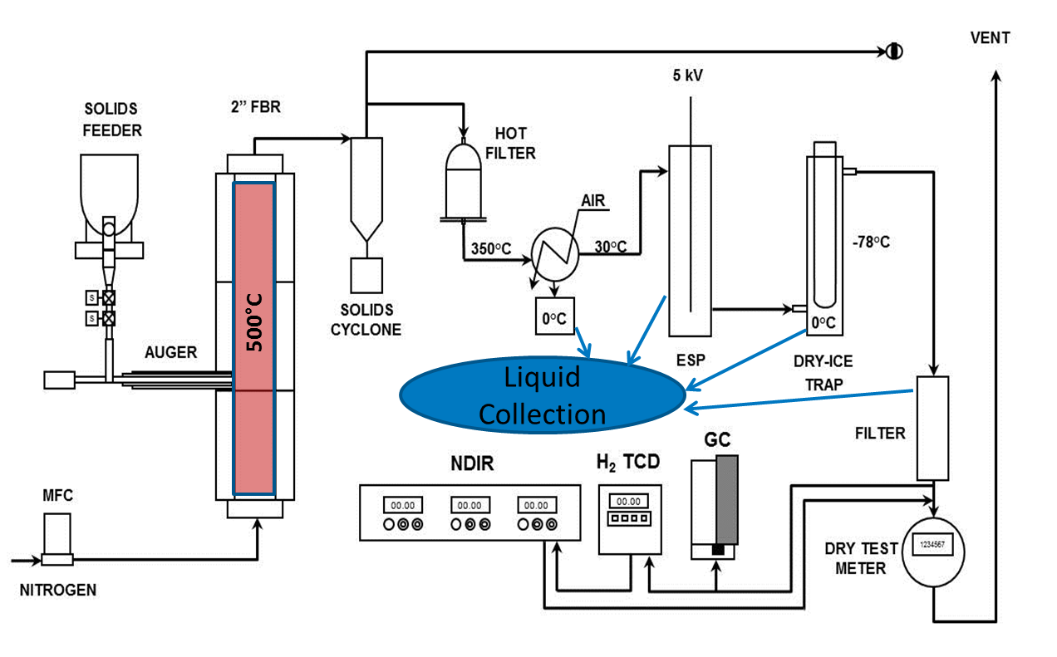
Figure S-1. Process flow diagram of NREL 2FBR system used to generate fast pyrolysis bio-oils from INL feedstocks.
Liquid products were condensed using an air-cooled condenser cooled by simple convection and allowed to flow into an ice-cooled, two-neck flask. The gas/aerosol phase passing out of the flask entered a 5 cm (2”) diameter electrostatic precipitator (ESP). The ESP was operated with a 5 kV potential on the central conductor and was also maintained at ambient temperature by air cooling. Liquids collected in the ESP were drained as needed into a 1 L sample bottle. The effluent passed into a cold finger dry ice trap and coalescing filter. All parts of the condensation train were weighed to obtain a raw oil yield and the collected liquids were brought to room temperature and combined in the 1 L bottle. The contents were then homogenized with a high shear mixer (LSK-1 with 2” slotted head, Charles Ross & Son Company®).

Permanent gases leaving the dry ice trap were sent to a dry test meter to measure total gas volume before venting. A slipstream of the vent gas was fed to a bank of analytical instruments to monitor gas composition in real time: a California Analytical Instruments Model300® NDIR for CH₄, CO, and CO₂; a thermal conductivity monitor TCM4 for H₂; and a three-channel Varian CP 4900 MicroGC for permanent gasses and C2/C3 hydrocarbons (MS-5A x 10m, PBQ x 10m, CP-Sil 5 x 8m).

Hydrotreating
The eight pyrolysis oils generated at NREL were upgraded at PNNL in a two-stage hydrotreater to produce a refinery-ready fuel. A process flow diagram is shown in Figure S-2. The hydrotreater had an inner diameter of 1.3 cm and an overall length of 63.5 cm. The first stage utilized a ruthenium catalyst on a carbon support. This catalyst was 7.8 wt% Ru prepared by impregnating ruthenium nitrosyl nitrate purchased from BASF on washed Norit ROX 0.8 CE purchased from Sigma-Aldrich using an incipient wetness procedure. At the reactor inlet, 2 g of the Ru/C extrudates were loaded as a “guard bed” to prevent plugging. This is necessary due to the non-isothermal zone at the reactor inlet, which can result in bio-oil polymerization. By adding the extrudates there is enough catalyst activity to prevent polymerization, but the lower active site density combined with the overall LHSV results in a negligible conversion contribution from the guard bed. From 5 cm to 32 cm within the reactor, 10 g of +30 to 60 mesh Ru/C was loaded. This reactor zone was kept at 220 °C and 10.3 MPa (1500 psi). The second zone, located at 32 cm to 64 cm, utilized a cobalt/molybdenum catalyst on an alumina support (cobalt oxide 3.4– 4.5%, molybdenum oxide 11.5 – 14.5%, on alumina, purchased from Alfa Aesar). Approximately 15 g of the catalyst was loaded in this zone, which was operated at 400 °C and 10.3 MPa (1500 psi). Prior to every experiment, the catalysts were sulfided by feeding Di-tert-butyl-disulfide to the reactor for approximately 12 hours via the ISCO syringe pumps seen in Figure S-2. The fast pyrolysis oil was fed to the reactor using a syringe pump. The total liquid flow rate for all experiments was 48 mL/hr. H₂, in stoichiometric excess, and He were fed to the top of the reactor along with the bio-oil. The liquid products were collected in a pressurized sample reservoir that was drained every six hours, and the oil and aqueous phases were subsequently gravity separated. The gases exiting the reactor passed through a Dry-Cal flow meter and were analyzed using an Agilent 3000A Micro-GC. The Dry-Cal flow meter and the gas chromatograph were operated continuously.

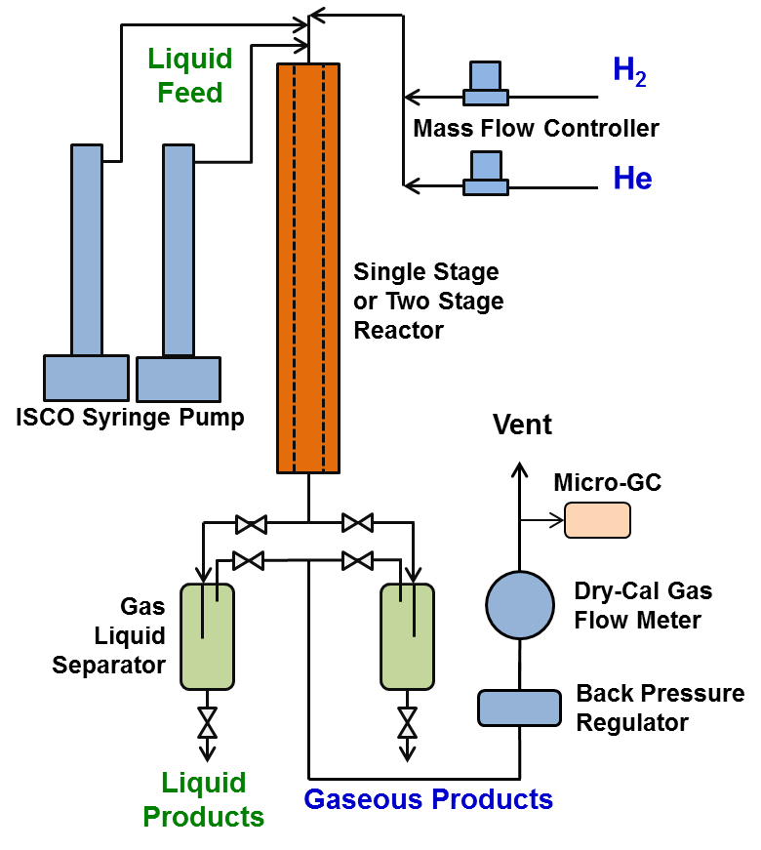
Figure S-2. Process flow diagram of the two-stage hydrotreater used to upgrade the fast pyrolysis bio-oils.
Feed and Product Characterization
Table S-1. Raw biomass feedstock properties as determined by proximate, ultimate, calorific, elemental ash, and compositional [1] analyses. Clean pine is debarked and delimbed whole trees. OSB is oriented strand board. Mass closure refers to compositional analysis.
Feedstock | Clean Pine | Switch-grass | Oriented strand board | Piñon-Juniper | Blend | Blend | Blend | Blend
Origin | Butler, AL | Garvin, OK | Bonneville, ID | Beaver, UT | various | various | various | various
Designation | CP | SG | OSB | PJ | CP₁TP₁  SG₁ | CP₈OSB₂ | CP₇OSB₂  SG₁ | CP₄OSB₂  SG₄
Proximate analysis (wt-% dry, ash-free) [unless otherwise noted]
Moisture (wt- %) | 3.50 | 6.66 | 2.39 | 9.75 | 4.19 | 3.76 | 4.08 | 4.66
Ash (wt-% dry) | 0.71 | 4.32 | 1.14 | 3.69 | 1.97 | 0.80 | 1.16 | 2.22
Volatile matter | 85.1 | 83.8 | 84.9 | 83.7 | 84.6 | 85.5 | 85.3 | 84.7
Fixed carbon | 15.0 | 16.2 | 15.1 | 16.2 | 15.4 | 14.5 | 15.1 | 15.5
HHV (MJ/kg) | 21.2 | 20.2 | 20.9 | 21.7 | 20.4 | 20.6 | 20.6 | 20.4
LHV (MJ/kg) | 18.1 | 17.0 | 17.7 | 18.0 | 17.1 | 17.5 | 17.4 | 17.3
Ultimate analysis (wt% dry basis, ash-free)
C | 51.4 | 50.8 | 50.7 | 55.1 | 50.4 | 50.8 | 50.8 | 50.6
H | 5.84 | 5.73 | 5.93 | 6.15 | 5.99 | 5.89 | 5.87 | 5.85
O (by diff.) | 42.6 | 42.9 | 42.8 | 38.3 | 43.2 | 43.1 | 43.1 | 43.1
N | 0.18 | 0.59 | 0.57 | 0.52 | 0.34 | 0.24 | 0.28 | 0.41
Elemental analysis (ppm, dry basis)
Al | 177 | 162 | 48 | 996 | 152 | 143 | 143 | 141
Ca | 950 | 2255 | 3829 | 8916 | 1623 | 1426 | 1569 | 1998
Fe | 138 | 151 | 70 | 692 | 143 | 137 | 137 | 136
Mg | 258 | 5607 | 397 | 921 | 1138 | 269 | 806 | 2417
Mn | 62 | 2445 | 17 | 33 | 47 | 51 | 289 | 1005
P | 79 | 821 | 117 | 481 | 357 | 75 | 151 | 378
K | 723 | 5607 | 1301 | 3171 | 2747 | 815 | 1306 | 2780
Si | 1367 | 12127 | 246 | 4400 | 5209 | 1064 | 2150 | 5407
Na | 51 | 497 | 908 | 222 | 214 | 217 | 262 | 398
S | 72 | 442 | 114 | 337 | 199 | 74 | 111.8 | 225
Ti | 12 | 13 | 17 | 73 | 11 | 143 | 143 | 141
Ash closure | 95.7 | 98.2 | 85.1 | 98.7 | 98.5 | 93.2 | 93.5 | 94.4
Compositional analysis (wt-% dry, ash-free basis)
H₂O ext. | 1.5 | 5.1 | 2.7 | 7.2 | 2.5 | 1.7 | 2.2 | 3.4
EtOH ext. | 2.8 | 2.5 | 2.9 | 7.0 | 1.9 | 2.8 | 2.7 | 2.6
Protein | 0.8 | 2.6 | 2.6 | 2.3 | 1.5 | 1.1 | 1.3 | 1.8
Glucan | 38 | 34 | 42 | 27 | 39 | 39 | 39 | 37
Xylan | 6.9 | 22.3 | 14.3 | 7.6 | 13.6 | 8.4 | 9.7 | 13.8
Galactan | 2.6 | 1.2 | 1.4 | 3.9 | 1.7 | 2.4 | 2.1 | 1.8
Arabinan | 1.3 | 2.9 | 1.0 | 3.2 | 1.7 | 1.7 | 1.3 | 2.1
Mannan | 12.8 | - | 2.8 | 4.5 | 5.7 | 10.2 | 9.7 | 5.2
Acetyl | 1.3 | 2.6 | 3.0 | 1.5 | 2.3 | 1.6 | 1.8 | 2.1
Lignin | 28.8 | 17.8 | 22.2 | 27.9 | 23.6 | 27.6 | 26.4 | 23.8
Mass closure | 96.8 | 94.9 | 94.7 | 91.9 | 94.7 | 96.3 | 96.2 | 95.2

The particle size distributions for the feedstocks used in this study are shown in Figure S-3. The distributions were fairly consistent, all falling between piñon-juniper and SG. Of the materials investigated for the study, the piñon-juniper material generated the largest particle sizes, SG was the smallest, and the whole pine, clean pine, OSB and blends were all similar in size. It should be noted that, although all feedstocks were pre-processed to pass through a 2.0 mm screen, the volume-weighted mean particle size was much smaller, ranging from ~0.5 mm for SG, to ~0.7 mm for the pinon-juniper.

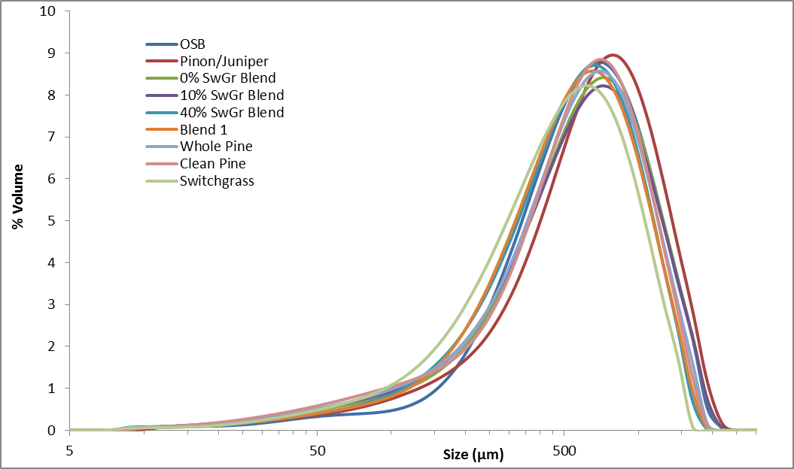
Figure S-3. Particle size distributions for the feedstocks used in this study.

Table S-2. Pyrolysis product distributions and analyses from NREL 2” fluidized bed reactor (“─” = below detection limits). Units are: water (KF-wt%), TAN (mg/g KOH), Carbonyl (mol/kg), Viscosity (cp, 40 °C), Density (g/cm3, 20 °C).
Feedstock | CP-1 | CP-2 | CP-3 | OSB | PJ | SG₄₅₀ | CP₁TP₁  SG₁ | CP₈ OSB₂ | CP₇OSB₂  SG₁ | CP₄SG₄  OSB₂
FP Product Yields (wt-% of biomass feed)
Total Liquid | 63.1 | 66.1 | 65.7 | 59.1 | 57.9 | 62.5 | 63.7 | 64.5 | 62.7 | 60.6
Char | 12.3 | 11.9 | 13.4 | 14.3 | 15.3 | 18.2 | 13.0 | 12.8 | 13.5 | 14.8
Gas | 17.7 | 16.2 | 15.8 | 20.3 | 17.5 | 13.9 | 17.0 | 17.5 | 17.4 | 17.8
Mass Balance | 93.1 | 94.2 | 94.9 | 93.7 | 90.7 | 94.6 | 93.7 | 94.6 | 94.2 | 93.6
FP Carbon Balance (wt-% of biomass feed carbon)
C_{oil} | 62.5 | 63.6 | 62.9 | 53.2 | 62.2 | 56.8 | 59.6 | 61.2 | 60.0 | 55.6
C_{char} | 20.7 | 20.0 | 22.1 | 22.8 | 21.3 | 24.3 | 19.0 | 20.9 | 20.9 | 23.0
C_{gas} | 14.2 | 13.3 | 12.6 | 14.8 | 13.5 | 10.6 | 13.3 | 13.8 | 13.3 | 13.9
carbon balance | 97.4 | 96.9 | 97.6 | 90.9 | 97.1 | 91.8 | 91.9 | 95.8 | 94.3 | 92.5
FP Oil Analysis (wt-% or ppm, as rec'd)
Ash (wt-%) | 0.54 | 0.53 | 0.11 | 0.67 | 0.34 | 0.16 | 0.37 | 0.21 | 0.42 | 0.30
C (wt-%) | 47.0 | 45.6 | 46.1 | 44.0 | 50.3 | 40.0 | 43.9 | 45.3 | 45.4 | 42.5
H (wt-%) | 7.5 | 7.4 | 7.5 | 7.8 | 8.6 | 7.9 | 7.6 | 7.6 | 7.6 | 7.9
N (wt-%) | 0.06 | 0.06 | 0.07 | 0.47 | 0.49 | 0.43 | 0.19 | 0.13 | 0.16 | 0.30
O (wt-%, by difference) | 44.9 | 46.4 | 46.2 | 47.1 | 40.3 | 51.5 | 48.0 | 46.8 | 46.5 | 49.0
S (ppm) | 50 | 45 | 55 | 50 | 280 | 375 | 100 | 80 | 55 | 175
Al (ppm) | < 1 | < 1 | < 1 | < 1 | < 1 | < 1 | < 1 | < 1 | < 1 | < 1
Ca (ppm) | 120 | 200 | 90 | 175 | 125 | 117 | 200 | 88 | 192 | 146
Fe (ppm) | < 1 | < 1 | < 1 | < 1 | < 1 | < 1 | < 1 | < 1 | < 1 | < 1
K (ppm) | < 20 | < 20 | < 20 | < 20 | < 20 | < 20 | < 20 | < 20 | < 20 | < 20
Mg (ppm) | 20 | 37 | 15 | 31 | 20 | 19 | 37 | 15 | 37 | 23
Na (ppm) | 104 | 24 | 88 | 24 | 87 | 72 | 23 | 84 | 23 | 86
P (ppm) | < 50 | < 50 | < 50 | < 50 | < 50 | < 50 | < 50 | < 50 | < 50 | < 50
Water | 21.7 | 20.4 | 20.5 | 25.6 | 27.6 | 29.8 | 23.6 | 21.6 | 23.9 | 26.4
Carbonyl | 5.59 | 5.53 | 5.39 | 3.91 | 2.88 | 4.60 | 4.88 | 4.92 | 4.53 | 4.48
TAN | 54.3 | 58.56 | 58.6 | 76.3 | 61.5 | 101.4 | 74.1 | 65.8 | 62.8 | 71.7
Viscosity | 44.6 | 55.0 | 47.6 | 39.1 | 947.0 | 20.9 | 34.1 | 42.5 | 50.1 | 29.8
Density | 1.18 | 1.20 | 1.20 | 1.12 | 1.08 | 1.18 | 1.17 | 1.21 | 1.21 | 1.23

Table S-3. Characterization of fast pyrolysis char and gas fractions from 2FBR.
Feedstock | CP-1 | CP-2 | CP-3 | OSB | PJ | SG₄₅₀ | CP₁ TP₁ SG₁ | CP₈ OSB₂ | CP₇ OSB₂ SG₁ | CP₄ SG₄ OSB₂
FP Char Analysis (wt-% or ppm as rec'd)
Ash (wt-%) | 5.1 | 5.1 | 5.4 | 8.0 | 18.5 | 23.7 | 13.3 | 3.9 | 9.3 | 14.4
C (wt-%) | 79.6 | 79.7 | 79.2 | 78.0 | 65.4 | 58.9 | 68.5 | 78.2 | 73.4 | 72.1
H (wt-%) | 4.6 | 5.0 | 4.8 | 4.2 | 3.8 | 4.2 | 4.5 | 4.5 | 4.3 | 4.2
N (wt-%) | 0.3 | 0.3 | 0.3 | 0.7 | 0.7 | 0.8 | 0.9 | 0.4 | 0.4 | 0.6
O (wt-%, by diff. | 10.5 | 9.7 | 10.5 | 9.2 | 11.3 | 12.2 | 12.0 | 12.5 | 12.4 | 8.9
Al (ppm) | 598 | 821 | 988 | 455 | 3402 | 374 | 776 | 436 | 349 | 452
Ca (ppm) | 10396 | 7019 | 8186 | 23654 | 51032 | 9036 | 11644 | 9211 | 8921 | 12037
Fe (ppm) | 1085 | 1569 | 1115 | 971 | 3955 | 517 | 1049 | 812 | 629 | 822
K (ppm) | 15150 | 5830 | 5870 | 9120 | 17310 | 23920 | 19780 | 5950 | 9390 | 19680
Mg (ppm) | 5750 | 2280 | 2620 | 2840 | 5600 | 9740 | 8600 | 2130 | 4780 | 7600
Na (ppm) | 1560 | 140 | 290 | 5050 | 420 | 1740 | 1310 | 1190 | 1200 | 2280
P (ppm) | 1850 | 600 | 700 | 850 | 3150 | 3300 | 2750 | 600 | 1000 | 2400
S (ppm) | 630 | 370 | 390 | 340 | 550 | 880 | 710 | 250 | 320 | 740
FP Nitrogen-Free Gas analysis (balance H₂)
CO (wt-%) | 41 | 43 | 42 | 33 | 30 | 27 | 36 | 39 | 37 | 34
CO₂ (wt-%) | 51 | 49 | 49 | 59 | 62 | 69 | 57 | 53 | 55 | 59
CH₄ (wt-%) | 4 | 5 | 5 | 4 | 4 | 2 | 4 | 4 | 4 | 4
C₂+ (wt-%) | 4 | 4 | 4 | 3 | 4 | 2 | 3 | 4 | 3 | 3

Table S-4. Hydrotreating product distributions and analyses from PNNL two-stage hydrotreater. Units of viscosity are cp, 40 °C; units of density are g/cm³, 20 °C. Boiling ranges are gasoline: 0-187 °C, kerosene: 160-266 °C, diesel: 187-345 °C, heavies: >345 °C; Units of H₂ consumption are g/g dry oil feed.
Feedstock | CP-1 | CP-2 | CP-3 | OSB | PJ | SG₄₅₀ | CP₁ TP₁ SG₁ | CP₈ OSB₂ | CP₇ OSB₂ SG₁ | CP₄ SG₄ OSB₂
HT Product Yields (wt-% of dry pyrolysis oil feed)
Fuel oil | 48.1 | 48.3 | 46.2 | 44.8 | 17.6 | 41.7 | 44.1 | 50.2 | 48.3 | 40.4
Water | 34.5 | 35.9 | 36.0 | 36.9 | 61.3 | 36.3 | 37.0 | 38.3 | 36.3 | 39.5
Gas | 17.4 | 15.8 | 17.8 | 18.3 | 21.1 | 22.0 | 18.9 | 11.5 | 15.4 | 20.1
HT Oil Phase Analysis
C (wt-%) | 87.8 | 88.0 | 88.1 | 87.5 | 86.9 | 87.5 | 88.0 | 88.2 | 88.0 | 88.0
H (wt-%) | 12.8 | 12.3 | 12.6 | 13.2 | 14.0 | 12.1 | 13.0 | 12.6 | 12.3 | 12.8
N (wt-%) | < 0.05 | < 0.05 | < 0.05 | < 0.05 | < 0.05 | < 0.05 | < 0.05 | < 0.05 | < 0.05 | < 0.05
O (wt-%, by difference) | 1.1 | 1.2 | 1.0 | 1.2 | 1.1 | 1.3 | 1.4 | 1.1 | 1.1 | 1.3
Si (ppm) | < 8 | < 8 | 10 | < 8 | 9 | < 8 | 21 | < 8 | < 8 | 10
S (ppm) | 208 | 52 | 49 | 30 | 53 | 44 | 56 | 44 | 63 | 49
Viscosity | 0.945 | 1.177 | 1.056 | 0.826 | 0.495 | 0.927 | 1.147 | 0.947 | 0.989 | 0.839
Density | 0.825 | 0.844 | 0.833 | 0.810 | 0.766 | 0.819 | 0.840 | 0.824 | 0.826 | 0.816
HT Aqueous Phase Analysis
C (wt%) | 0.15 | 0.14 | 0.19 | 0.76 | 0.20 | 0.50 | 0.42 | 0.34 | 0.32 | 0.35
N (wt%) | 0.18 | 0.15 | 0.19 | 0.92 | 0.36 | 0.60 | 0.35 | 0.28 | 0.32 | 0.46
K (ppm) | < 1.5 | < 1.5 | < 1.5 | < 1.5 | < 1.5 | < 1.5 | < 1.5 | < 1.5 | < 1.5 | 3
Na (ppm) | 12 | 7 | 9 | 8 | 9 | 8 | 7 | 11 | 7 | 9
Si (ppm) | 16 | 21 | 14 | 12 | 13 | 17 | 32 | 17 | 13 | 8
S (ppm) | 59 | 16 | 14 | 391 | 335 | 147 | 66 | 38 | 53 | 57

Yield model supporting details
Figure S-4. Yields from fast pyrolysis (FP), hydrotreating (FP), and combined fast pyrolysis and hydrotreating (FP+HT) processes for several biomass feedstocks as a ratio of dry oil product to dry infeed material. Results from similar tests using different feedsto as reported by Howe et al. [4] are included for comparison and are marked with *. Note that sample CP*-2 was labeled Wh-Pn in Howe et al.
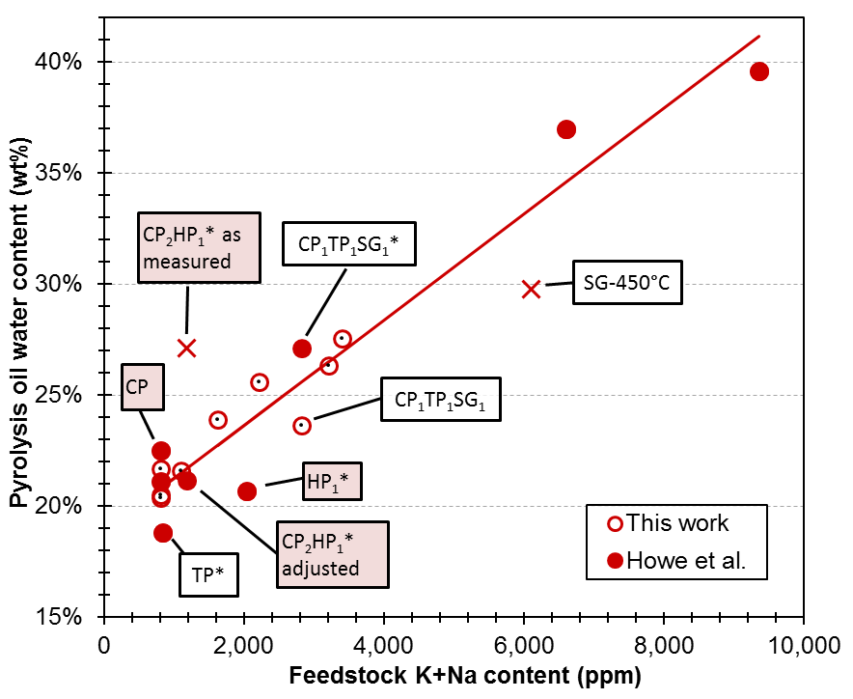
Figure S- 5. Water content of fast pyrolysis oils as a function of the K+Na content of the raw feedstock/blend.

Table S-5. Weighted-average estimated yields. Fast pyrolysis and hydrotreating oil mass yields and improved estimated yields using multivariate analysis. All values are reported on a dry, ash-free basis.
 | Fast pyrolysis mass yield |  |  |  | Hydrotreating mass yield
 | As Det. | Estimate | Difference |  | As Det. | Estimate | Difference
CP*-1 | 53.1% | 52.9% | 0.2% |  | 51.5% | 49.6% | 2.0%
CP*-2 | 50.1% | 52.9% | -2.9% |  | 50.1% | 49.6% | 0.5%
CP-1 | 52.1% | 52.9% | -0.9% |  | 48.1% | 49.6% | -1.5%
CP-2 | 55.5% | 52.9% | 2.5% |  | 48.3% | 49.6% | -1.3%
CP3 | 54.9% | 52.9% | 2.0% |  | 46.2% | 49.6% | -3.4%
CP-ave | 53.1% | 52.9% | 0.2% |  | 48.8% | 49.6% | -0.7%
CP₁TP₁SG₁* | 49.6% | 51.3% | -1.7% |  | 49.5% | 44.2% | 5.2%
CP₁TP₁SG₁ | 51.9% | 51.3% | 0.6% |  | 44.1% | 44.2% | -0.1%
CP₁TP₁SG₁-ave | 50.7% | 51.3% | -0.5% |  | 46.8% | 44.2% | 2.5%
HP* | 54.0% | 52.9% | 1.1% |  | 46.0% | 47.1% | -1.1%
TP* | 60.3% | 59.9% | 0.4% |  | 40.1% | 41.8% | -1.7%
SG* | 40.8% | 40.9% | -0.1% |  | 41.6% | 41.4% | 0.2%
SG-450°C | 49.1% | 49.1% | 0.0% |  | 41.7% | 41.7% | 0.0%
OSB | 45.6% | 46.1% | -0.5% |  | 44.8% | 44.3% | 0.5%
CP₂HP₁ | 49.7% | 52.9% | -3.2% |  | 51.9% | 48.7% | 3.2%
CP₈OSB₂ | 53.0% | 51.6% | 1.4% |  | 50.2% | 48.5% | 1.7%
CP₇OSB₂SG₁ | 50.3% | 50.4% | 0.0% |  | 48.3% | 47.7% | 0.6%
CP₄OSB₂SG₄ | 47.9% | 46.8% | 1.1% |  | 40.4% | 45.3% | -4.9%
Note: Improved estimated values were not determined for CS* and P-J because those samples were not included in any blends or replicates.

To assess the robustness of the proposed models, a cross validation was performed by removing all samples containing each feedstock (including the blends) for each cross validation iteration. The RMSECV reported in Table S-6 is the average of seven cross validation iterations that were each generated by removing a single feedstock from the model and then testing the model on samples that included the removed feedstock as a pure material or as a blend. The poorest cross validation model for every variable combination in Table S-6 was the model in which the clean pine samples were removed. This result is expected because clean pine has the most replicates and is included in a majority of the blends). The RMSECV for the (VM, Lig) model for which all samples that contain clean pine were removed is 2.1% which is still within the experimental uncertainty of 3.6%. When either of the herbaceous sample replicates are removed, switchgrass or corn stover, the model is relatively stable with RMSECVs of 1.48% and 1.72%, respectively, indicating that the leverage for all samples is within the overall estimated uncertainty.

Table S-6. Summary of fitting parameters for models to predict estimated pyrolysis oil yield (wt% dry, ash-free basis). Inorganic species including total ash are treated as loading of analyte per quantity of dry organic matter.
Predictor variables | Model type | R² | RMSEC | RMSECV
VM | Univariate | 0.69 | 2.8 | 4.0
Lig | Univariate | 0.69 | 3.2 | 4.0
K+Na | Univariate | 0.83 | 2.2 | 2.0
Total ash | Univariate | 0.72 | 2.8 | 3.8
K+Na+Mg+Ca | Univariate | 0.72 | 2.8 | 3.4
VM, Lig | Multivariate | 0.94 | 1.3 | 1.8
VM, K+Na | Multivariate | 0.91 | 1.6 | 1.9
VM, Lig, K+Na | Multivariate | 0.94 | 1.3 | 2.2
VM = volatile matter; Lig = Lignin; K+Na = sum of potassium and sodium; K+Na+Mg+Ca = sum of potassium, sodium, magnesium, and calcium; RMSEC = root mean squared errors of the model calibration data set; RMSECV = root mean of the squared errors of the cross validation data set.

As shown in the final row of Table S-6, adding K+Na as a third fitting parameter along with volatile matter and lignin, does not significantly improve the fit to the fast pyrolysis oil yield data but does increase the root mean square cross validation error (RMSECV). Another important consideration is that lignin and K+Na contents are substantially correlated because the herbaceous feedstocks consistently have low lignin contents and high ash contents. Thus, distinguishing the impact of lignin from the impact of K+Na is difficult due to multicollinearity of the predictor variables. Including both variables in the same model risks fitting noise in the data rather than modeling actual variable impacts. Additional tests using samples in which lignin and K+Na are not closely correlated will be needed to determine the separate impacts of those predictor variables.

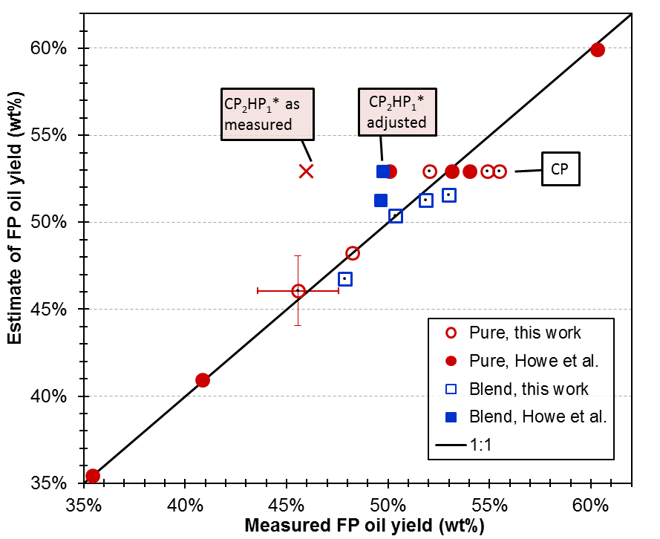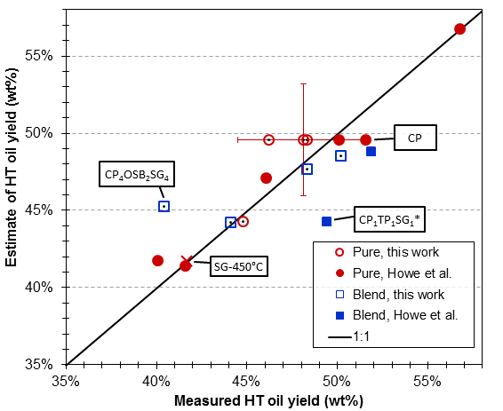
(a)
(b)
Figure S-6. Comparison of measured fast pyrolysis oil yields (a) and hydrotreating yields (b) with the estimates of the oil yields for each material from multivariate analysis. Pure feedstocks are shown as circles while blends are shown as squares. Example uncertainty bar are shown only on one sample to avoid multiple overlapping lines.

